1. 
2. **Agenda**:
   1. How to add text?
   2. How to format text to help the information stand out.
3. 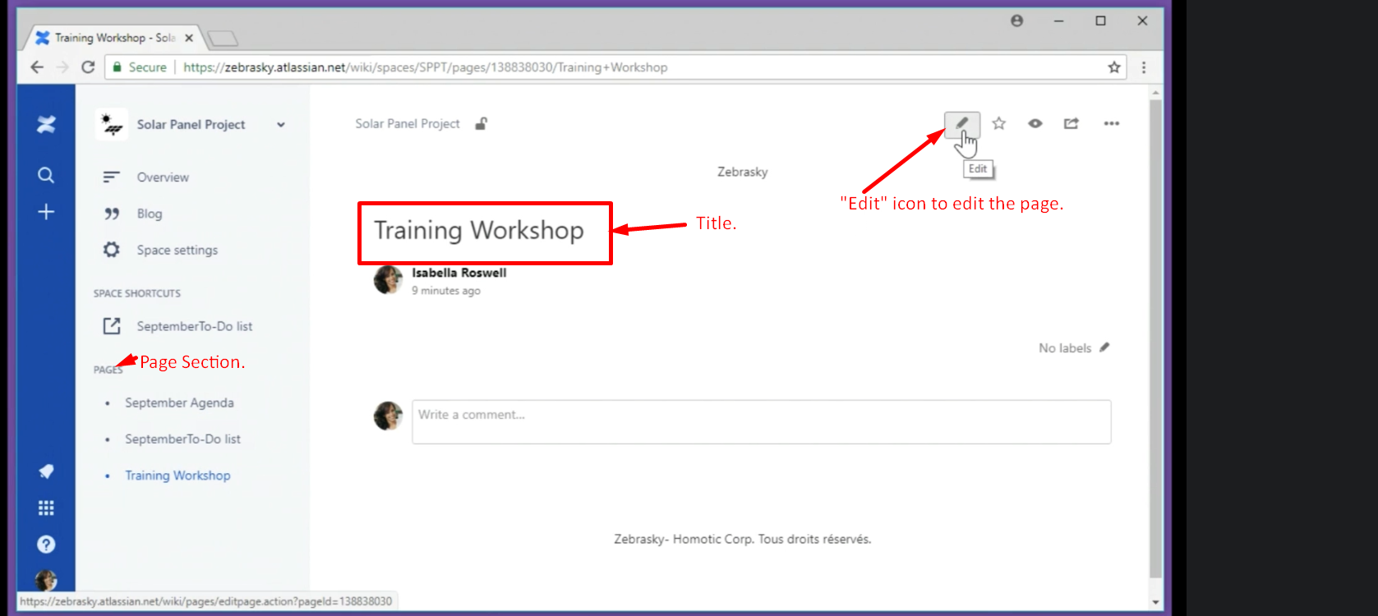
4. 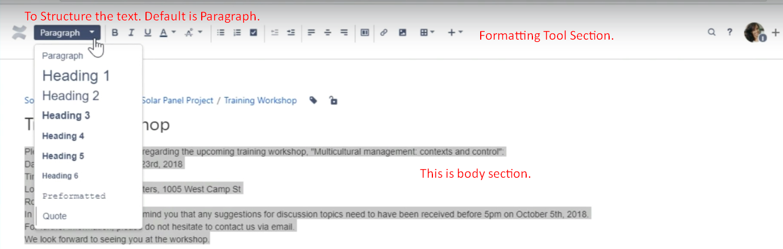
5. 